TABLE OF CONTENTS
Abstract...........................................................................…….. 2
- Introduction.........................................................................3
- Problem Definition............................................................… 5
- Project Objectives............................................................…. 6
- SDG Alignment.................................................................….6
- Software Development Life Cycle (SDLC).........................…….7
- System Requirements......................................................…. 8
- Use Case Diagram..........................................................…...9
- UML Class Diagram......................................................…… .10
- System Architecture Design...........................................…… 12
- Prototype Development..............................................……… 15
- Git & GitHub Integration............................................………. 18
- Project Management..................................................…….. .20
- Software License........................................................…….. 24
- UI/UX Design Quality.................................................……… 24
- Expected Benefits......................................................……… 25
- Conclusion..................................................................……. 26
- References.........................................................................27

SIERRALT SYSTEM

Disaster Alert System for Sierra Leone

ABSTRACT
Sierra Leone continues to face frequent natural disasters such as floods, landslides, storms, and fire outbreaks, which often result in loss of lives, displacement of people, and destruction of property. One of the key challenges in disaster management is the delay in communication between authorities and citizens, which reduces the effectiveness of emergency response.
This project presents the Sierralt System, a Digital Public Good designed to improve disaster communication, preparedness, and response in Sierra Leone. The system connects citizens, the National Disaster Management Agency (NDMA), and the Meteorological Service (MET Service) through a centralized platform that delivers real-time alerts, hazard reporting, and emergency information.
The system is developed using the Agile Software Development Life Cycle (SDLC) model to allow flexibility and continuous improvement. It supports Sustainable Development Goal 13 (Climate Action) by enhancing disaster preparedness and strengthening climate resilience through technology.

1. INTRODUCTION
Technology has become an essential tool for solving social, economic, and environmental challenges in today's world. Governments, organizations, and communities increasingly rely on digital systems to improve communication, service delivery, and decision-making processes. In recent years, Digital Public Goods (DPGs) have gained significant importance because they provide innovative solutions that benefit society while supporting sustainable development objectives.
Sierra Leone is among the countries that face numerous environmental and climate-related challenges. Natural disasters such as floods, landslides, storms, and fire outbreaks occur frequently and often have devastating consequences. These disasters result in injuries, loss of lives, destruction of infrastructure, displacement of families, and economic losses. Climate change, poor urban planning, blocked drainage systems, and deforestation have further increased the frequency and severity of these disasters.
One of the major difficulties experienced during disasters is the delay in communication between authorities and citizens. Emergency information is often transmitted through traditional methods such as radio broadcasts, public announcements, and word-of-mouth communication. While these methods can be useful, they are often slow, limited in reach, and ineffective during rapidly developing emergency situations.
The tragic Regent Landslide of 2017 highlighted the need for improved disaster management and communication systems in Sierra Leone. The disaster caused significant loss of life and exposed weaknesses in emergency preparedness and information dissemination. Since then, there has been growing recognition of the importance of utilizing digital technologies to improve disaster response and risk reduction.
To address these challenges, this project proposes the development of the SIERRALT SYSTEM, a Disaster Alert System designed specifically for Sierra Leone. The system aims to provide a centralized digital platform that facilitates communication between citizens, disaster management authorities, and weather monitoring agencies. By integrating disaster alerts, weather monitoring, hazard reporting, emergency shelter information, and safety guidelines into a single platform, the system can significantly improve disaster preparedness and emergency response.
The Sierralt System enables citizens to receive real-time alerts regarding potential disasters, report hazardous conditions within their communities, access emergency information, and locate available shelters during emergencies. At the same time, the National Disaster Management Agency (NDMA) can use the system to coordinate disaster response activities, review hazard reports, and communicate directly with affected communities. The Meteorological Service can provide weather information and trigger automated alerts when dangerous conditions are detected.
The implementation of this system contributes directly to Sustainable Development Goal 13 (Climate Action) by enhancing disaster preparedness, reducing disaster-related risks, and strengthening community resilience. Through the use of modern digital technologies, the Sierralt System provides a practical and sustainable solution to disaster management challenges in Sierra Leone.

2. PROBLEM DEFINITION
Sierra Leone faces frequent disasters that are poorly managed due to weak communication systems. Citizens often receive warnings too late, reducing their ability to respond effectively.
Another major issue is the lack of a proper hazard reporting system. Dangerous conditions such as blocked drainage systems, flooding, and fire outbreaks are often not reported in time.
Emergency response agencies also struggle with incomplete or delayed information, making it difficult to coordinate effective responses.
These challenges lead to:
- Loss of lives
- Property destruction
- Economic losses
- Poor emergency coordination
- Increased vulnerability to climate change
A modern digital system is needed to solve these problems by improving communication and response efficiency.

3. PROJECT OBJECTIVES
The objectives of the Sierralt System include:
- Provide early disaster warning alerts
- Improve communication between citizens and authorities
- Enable hazard reporting in real time
- Improve emergency response coordination
- Increase public disaster awareness
- Support climate resilience initiatives
- Reduce disaster-related losses

4. SDG ALIGNMENT
The Sierralt System supports United Nations Sustainable Development Goal 13 (Climate Action) by improving disaster preparedness and climate resilience.
It contributes by:
- Providing early warning systems
- Improving weather monitoring
- Supporting disaster risk reduction
- Enhancing community resilience
- Promoting climate adaptation strategies
- Improving emergency coordination

5. SOFTWARE DEVELOPMENT LIFE CYCLE (SDLC)

Agile Model
The Agile model is used due to its flexibility and ability to support continuous improvement.

Requirements Gathering
Requirements were collected from citizens, NDMA, and MET Service.
Key needs include alerts, hazard reporting, shelter management, and weather monitoring.

System Analysis
The system was analyzed in terms of functional and non-functional requirements, including security, scalability, and usability.

System Design
Design includes database structure, user interfaces, and system architecture.

Development
System modules include:
- User management
- Alert system
- Hazard reporting
- Weather monitoring
- Shelter management

Testing
Testing includes:
- Unit testing
- Integration testing
- System testing
- User acceptance testing

Deployment
The system is deployed on cloud infrastructure and made accessible via mobile and web platforms.

Maintenance
Ongoing updates include bug fixes, performance improvements, and feature upgrades.

6. SYSTEM REQUIREMENTS

Functional Requirements
- User registration and login
- Disaster alert notifications
- Hazard reporting system
- Flood risk maps
- Emergency contacts
- Shelter information
- Weather updates
- Incident reporting

Non-Functional Requirements
- Security
- Reliability
- Scalability
- Performance
- Availability
- Usability
- Maintainability

7. USE CASE DIAGRAM

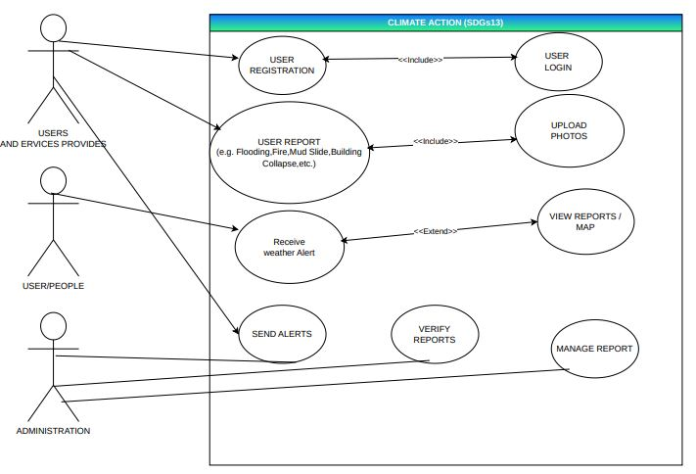

Explanation
The system has three main actors:
- Citizens
- NDMA Administrators
- Meteorological Service
Citizens receive alerts and submit reports. NDMA manages disasters and shelters. MET Service provides weather data for alerts.
8. UML CLASS DIAGRAM

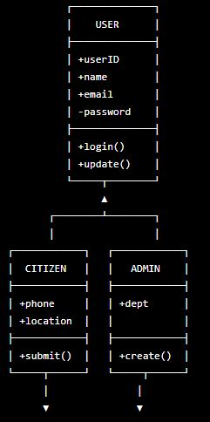

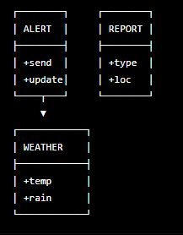

Explanation
Main classes include:
- User
- Citizen
- Admin
- WeatherService
- HazardReport
- Alert
- Shelter
- IncidentReport
These classes manage authentication, reporting, alerts, and disaster data processing.

9. SYSTEM ARCHITECTURE DESIGN

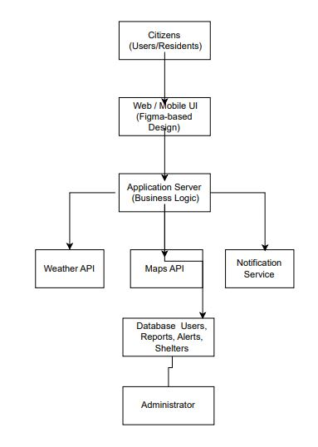

Explanation
The system uses a centralized client-server architecture consisting of:
- Citizen mobile/web interface
- NDMA admin dashboard
- Application server
- Database
- Notification system
- Weather integration system
Data flows from users and MET Service to the server, which processes and sends alerts through SMS, email, and push notifications.

10. PROTOTYPE DEVELOPMENT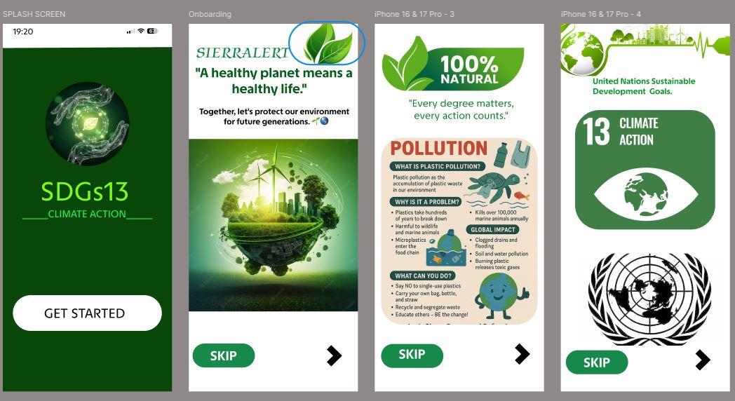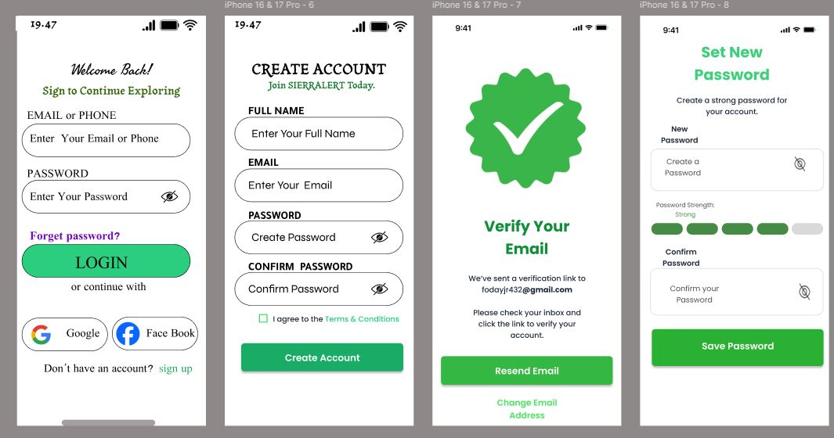

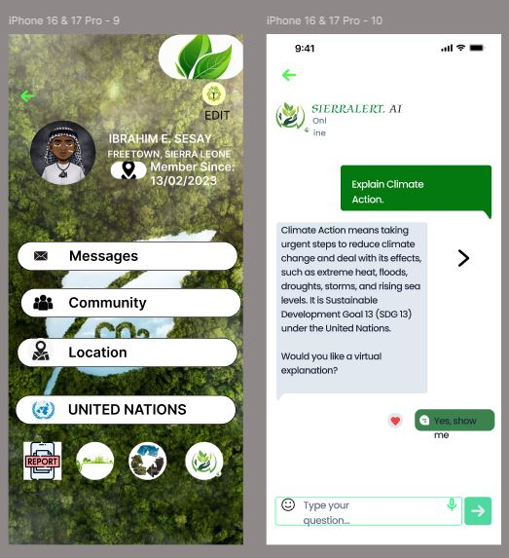

Explanation
The prototype includes:
- Login and registration screens
- Citizen dashboard
- Alert screen
- Hazard reporting screen
- Flood map screen
- Safety guidelines
- Emergency contacts
- NDMA dashboard
The UI is designed to be simple, accessible, and responsive.

11. GIT & GITHUB INTEGRATION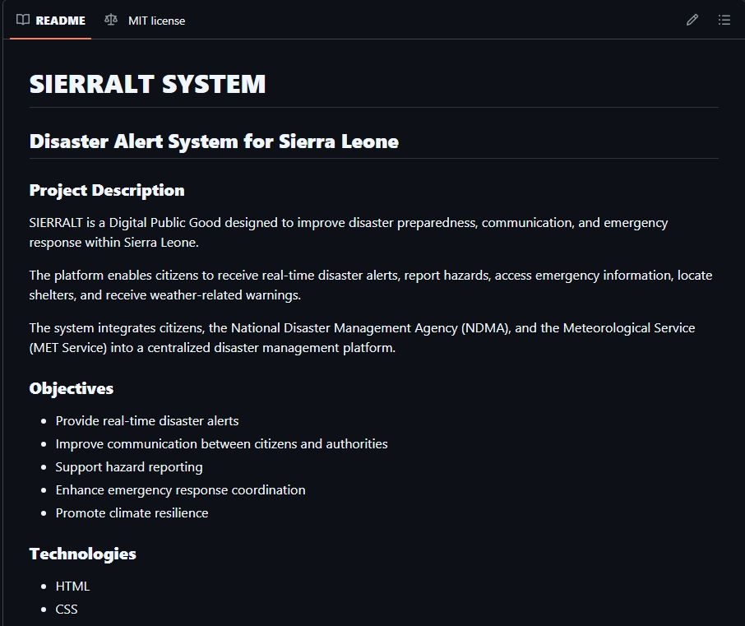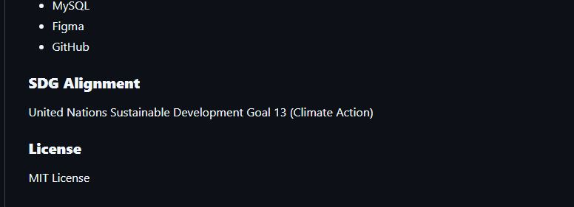
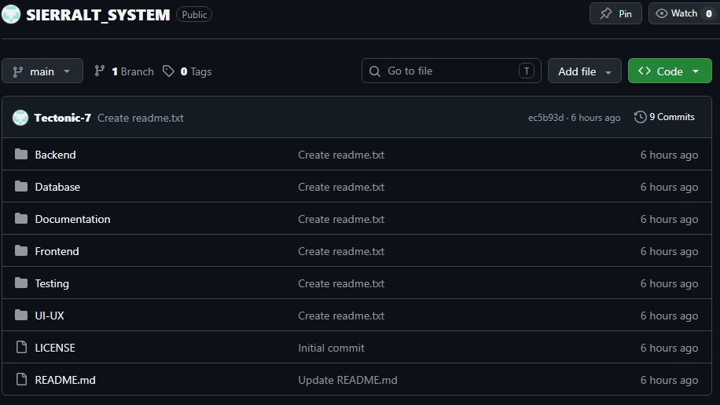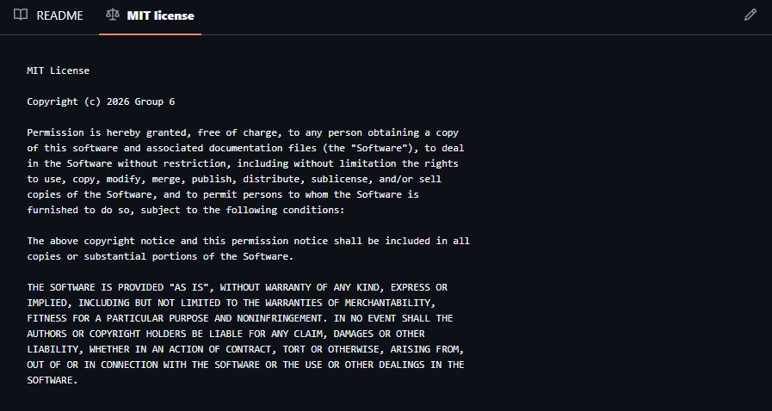GitHub is used for version control and collaboration.
Benefits include:
- Tracking changes
- Collaboration among group members
- Backup of project files
- Efficient project management

12. PROJECT MANAGEMENT

Gantt Chart

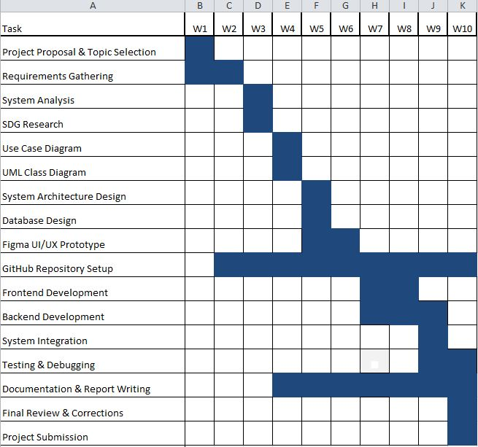

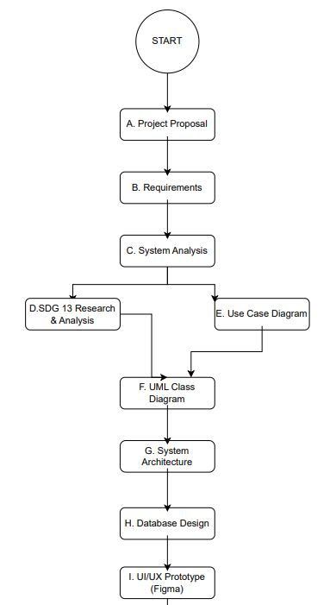

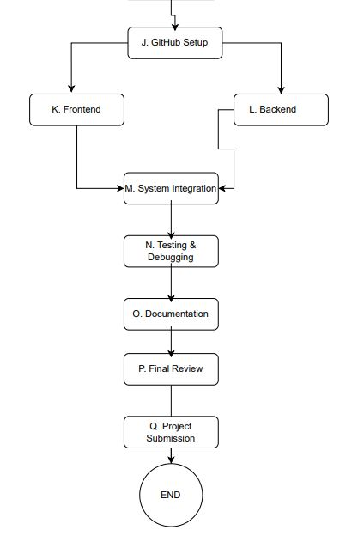

NETWORK DIAGRAM

Explanation
The project follows a structured timeline:
- Requirements → Analysis → Design → Development → Testing → Documentation → Submission
The Gantt chart shows task scheduling across 10 weeks, while the network diagram shows task dependencies.

13. SOFTWARE LICENSE
The project uses the MIT License, which allows free use, modification, and distribution of the software.
It is suitable for Digital Public Goods because it promotes openness and collaboration.

14. UI/UX DESIGN QUALITY
The system follows key UI/UX principles:
- Simplicity
- Consistency
- Accessibility
- Responsiveness
- Clear navigation
Color usage:
- Red → Alerts
- Blue → Information
- Green → Safety
The design ensures users can quickly access emergency information.

15. EXPECTED BENEFITS
- Faster emergency communication
- Reduced disaster response time
- Improved public safety
- Better coordination between agencies
- Increased disaster awareness
- Reduced loss of lives and property
- Stronger climate resilience

16. CONCLUSION
The Sierralt System provides a practical digital solution to improve disaster management in Sierra Leone. By integrating alerts, hazard reporting, weather monitoring, and emergency coordination into one platform, the system improves communication between citizens and authorities.
It supports Sustainable Development Goal 13 by enhancing climate resilience and disaster preparedness. With proper implementation, the system can significantly reduce disaster risks and improve national emergency response capacity.

REFERENCES
National Disaster Management Agency (NDMA), 2024. Disaster Management Reports. Freetown: NDMA.
Pressman, R.S. and Maxim, B.R., 2020. Software Engineering: A Practitioner’s Approach. 9th ed. New York: McGraw-Hill.
Sommerville, I., 2016. Software Engineering. 10th ed. Harlow: Pearson.
United Nations, 2015. Sustainable Development Goals Report. New York: UN.
UNDRR, 2024. Disaster Risk Reduction Framework. Geneva: United Nations.
World Bank, 2023. Climate Risk and Disaster Report. Washington DC: World Bank.
WMO, 2024. Early Warning Systems Report. Geneva: World Meteorological Organization.

